
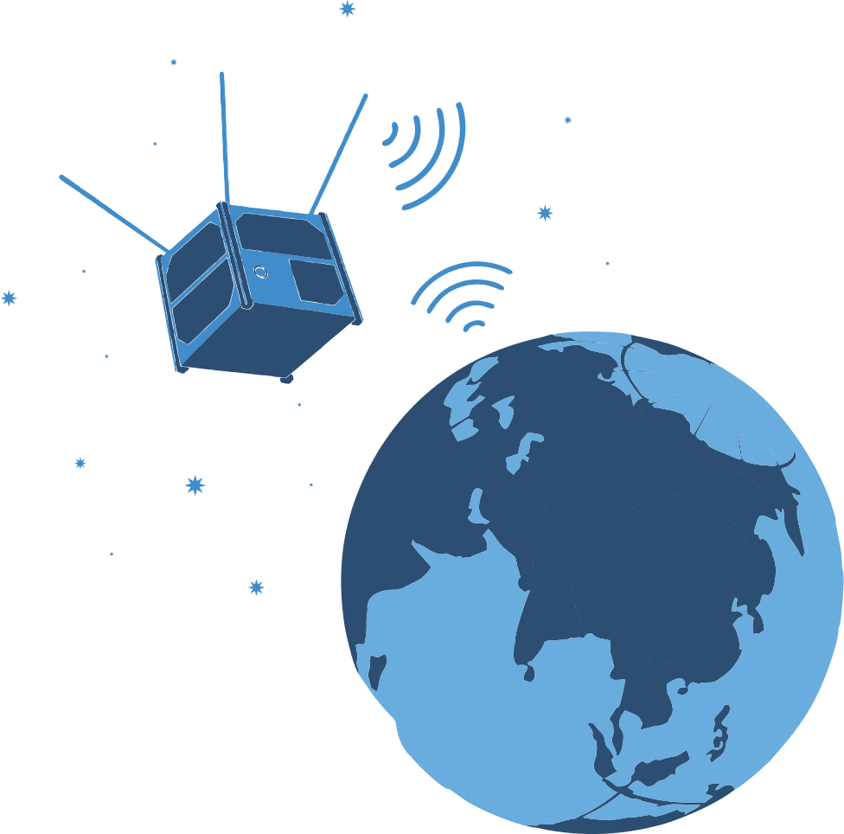
CUBESAT
PRESENTATION OF THE SELECTION STAGES
BAKU 2025

Team name:

School name, number and address:

Team leader:
Contact number:

Student 1:

Student 2:

About CubeSats
(Explain the elements used in the model prepared here, the functions they perform, the design of the CubeSat, its dimensions, weight, etc., its advantages)

Wireless communication with CubeSat
(This should be a video of the model being prepared transmitting data wirelessly. The video link in YouTube format should be posted here for 60-90 seconds)

Team photo
(This should include a photo of all team members at work or in front of the drone)

- Technical name and images of the elements used
  - Sensors (names and pictures)
(If more than 1 sensor is used here, the name and picture of each should be listed separately)

  - Main controller (name and picture)

  - Wireless connection used (name and image)

  - CubeSat fuselage design (image in design software)

CubeSat photo images
(Here, the size should be visible with a ruler next to the model in each photo)
  - From the left

  - From the right

  - From the front

  - From behind

  - From above

  - From below

Satellite Model Photo Images
  - From the front

  - From above

