
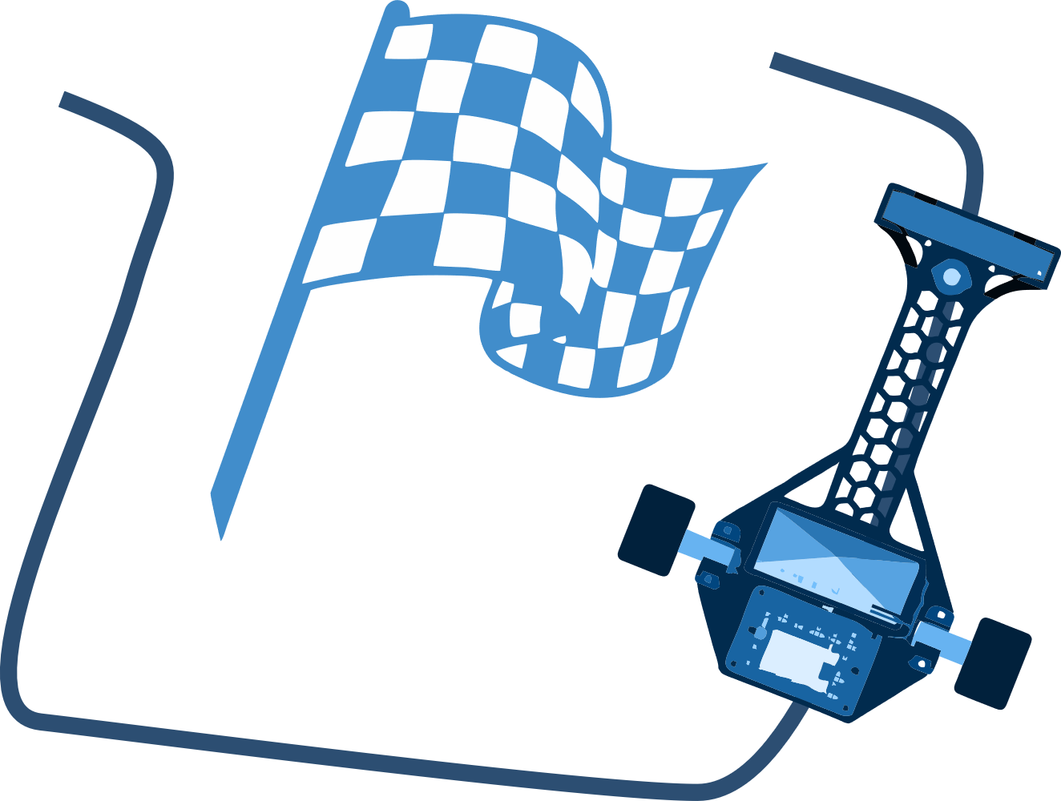
FAST AND FURIOUS
PRESENTATION OF THE SELECTION STAGE
BAKU 2025

Team name:

School name, number and address:

Team leader:
Contact number:

Student 1:

Student 2:

- About the robot
(Explain the elements used in the model prepared here, the functions they perform, the robot's design, dimensions, weight, etc., in terms of its advantages)

2.Line tracking with a robot
(This should be a video of the robot being prepared realistically following a line (on a circular or oval-shaped map). (You should post the video link in YouTube format in 1080p quality for 60 seconds):
In the introductory part of the video material, the participant states his/her name, surname and team name, then SAF2025 Fast and Furious “I am presenting for the category". It is prohibited to add additional sounds, songs, and transitions to the prepared video material.

Width 50cm, length 100cm. Diameter 100cm

3.Team photo
(This should include a photo of all team members at work or in front of the robot)

4.Technical name and images of the elements used
4.1 Sensors (names and pictures)
(This should include information about the line tracking sensor used)

4.2 Main control card (name and picture)

4.3 Motor driver (name and picture)

4.4 DC motors (name, technical specifications and picture)

4.5 Wireless connection used (name and image (if available))

4.6 Design of the robot-body element (drawing in the design program)

5.Photo images of the robot
(Here, the size should be visible with a ruler next to the model in each photo)
5.1 From the left

5.2 From the right

5.3 From the front

5.4 From behind

5.5 From above

5.6 From below

